**Lookbook Requirements**

**As of 2/14/12**

Lookbook –New Feature Needed ASAP for Kmart Fashion Spring, DOL, Sofia, StyleSIp Spring, Bongo, Glo, Jaclyn Smith lookbooks.

**CURRENT LOOKBOOK in PRODUCTION**

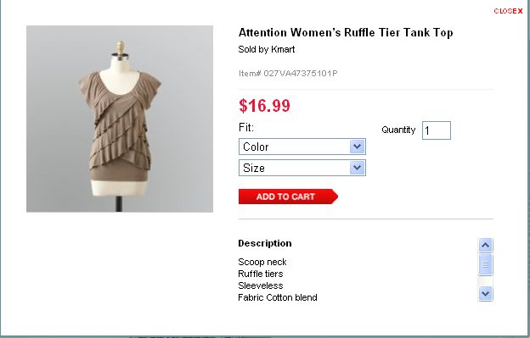

**Priority 1:** When selecting the color in the drop down menu, the PID needs to reflect the color selection

Step 1: Select product – Sofia by Sofia Vergara Women’s Ruffle Tunic

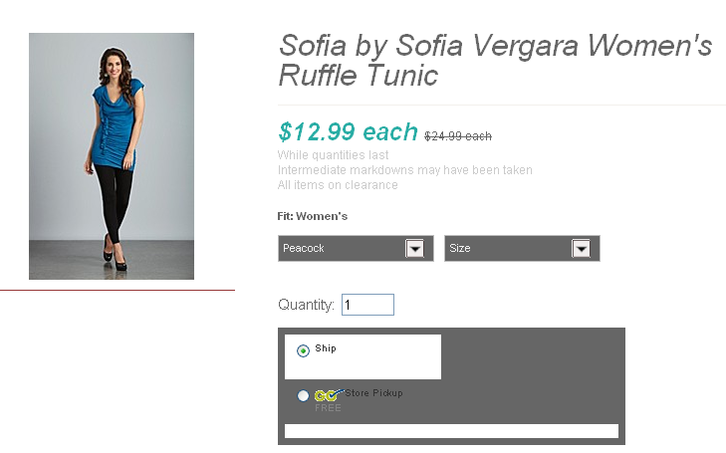

Step 2: Chose Watermelon (PID image is updated)

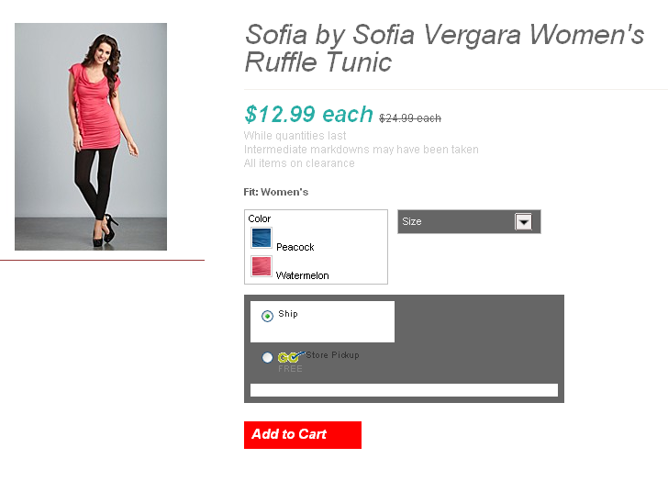

**Priority 2:** Remove the word fit from quick view – circled in red

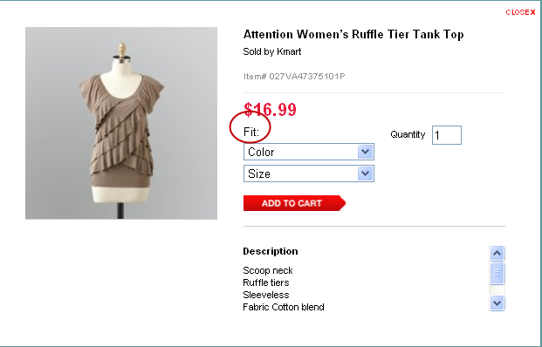

**Priority 3:** Continue Shopping – When you select a color and size and then click on “Add To Cart” you need to have a CTA to continue shopping in a new window with the following items:

-**How many items are added to your cart**

**-Product Name**

**-Sold by Kmart**

**-Price**

**-Color**

**-Special Sizes**

**-Size**

**-Quantity**

**-Click to Continue Shopping**

**-Link to View cart and checkout**

When you click on “Continue Shopping” the new window closes and shows the product quickview.

When you click on “View Cart and Checkout” the page goes to the Shopping Cart page on WCS and shows what images are in your cart. When you click on “Close” the Item added window will close.

New Window: Final creative will be set up for approval on copy and colors

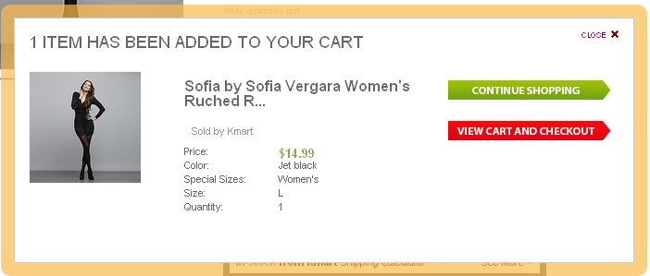

**Priority 4**: Link to Brandshop instead of KmartFashion or Stylesip on each lookbook

1. “Return” to link must be customizable –done
2. Text of the return to needs to be cust. and preferably not a image

Return to Kmart Fashion – link in existing window to: (IN PRODUCTION)

<http://www.kmart.com/shc/s/dap_10151_10104_DAP_KmartFashion>

Return to Sofia Vergara- link in existing window to: <http://www.kmart.com/shc/s/dap_10151_10104_DAP_Sofia>

Return to StyleSip – link in existing window to:

<http://www.kmart.com/shc/s/dap_10151_10104_DAP_Style+Sip?adCell=W3>

Return to Dream Out Loud – link in existing window to: <http://www.kmart.com/shc/s/dap_10151_10104_DAP_Dream+Out+Loud?adCell=W3>

Return to Glo – link in existing window to: <http://www.kmart.com/shc/s/dap_10151_10104_DAP_Glo+Jeans?adCell=W3>

Return to Bongo – link in existing window to:

<http://www.kmart.com/shc/s/search_10151_10104?vName=Clothing&cName=Juniors&viewItems=25&redirectType=CAT_R&keyword=bongo+juniors&i_cntr=1326318362709&autoRedirect=true>

Return to Jaclyn Smith – link in existing window to: <http://www.kmart.com/shc/s/dap_10151_10104_DAP_JaclynSmith>

**Priority 5**: When you rollover the PID in the quickview window, a small window will show up and then would show a larger image of the product next to the PID window

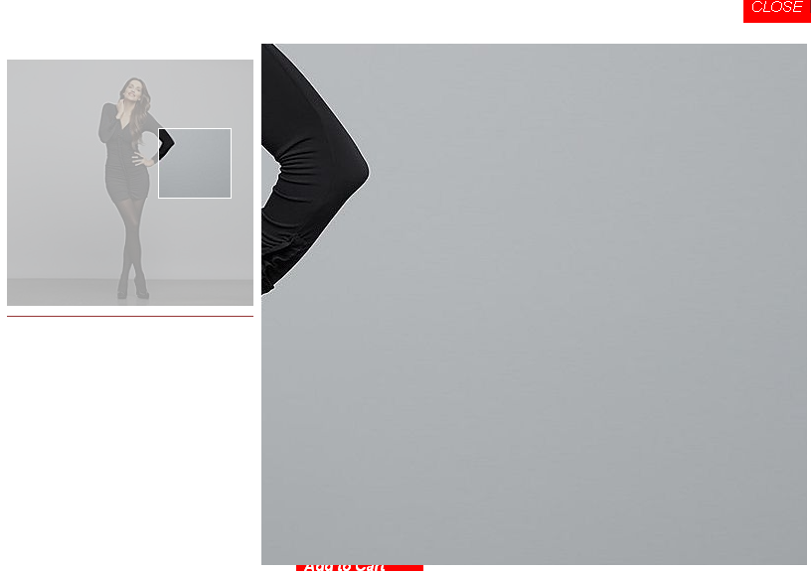

**Priority 6:** Add a link to the QV to link to the Product Details page in a new window.

